Press Release

Method Park launches Stages 7.6
The new version of the process management tool Stages strengthens Method Parks offering for complex engineering projects. It comes with new integrations into Atlassian Jira and IBM Engineering Workflow Management.
Erlangen, February 25, 2021 – Stages 7.6 brings innovative new capabilities that speed up the whole lifecycle from implementation, review and release of a process change to its practical execution in the context of a project or program. This makes it easier to use processes in practice and does not remain theoretical overhead.
The process is working for the user
To assure that processes are applied in practice, the defined process activities need to be planned, executed, and monitored. The latter typically happens in task management tools like Atlassian Jira or IBM Engineering Workflow Management (formerly known as Rational Team Concert or RTC). The new Stages integration allows to map the relevant processes onto the new “activator” elements and deploy the resulting executable models directly into the task management tools.
Stages comes with a set of out-of-the-box activators, which enables a quick return-on-invest of process execution projects, but the technical execution can also be scripted for more flexibility.

Consistent process interfaces
Complex engineering processes need to have a clear architecture of different functions, disciplines, or process areas with well-defined interfaces to each other. To manage those interfaces in a consistent way, Stages 7.6 allows to group certain process workspaces into collections. Within a collection, process authors automatically get proposals for process interfaces during their usual modeling practice.
This avoids duplications and other potential inconsistencies and greatly speeds up modeling large process landscapes.
More process releases in less time
With version 7.6, a new process release capability replaces manual review, approval, and update efforts with automated steps. This enables organizations to perform more process optimizations in less time, allowing faster reactions to external changes and improving organizational agility while still having controlled and documented approvals in place.
Please find more information on Stages, its features, and benefits on the Method Park website:
https://www.methodpark.com/stages.html
Number of characters (space characters included): 2,210
About Method Park
Method Park specializes in complex product engineering in the environments of the automotive, medical, and aerospace industries. Method Park’s portfolio includes consulting and engineering services, a comprehensive training program, and the process management tool “Stages”.
Method Park was founded in 2001. The company has coached its customers on process optimization worldwide, compliance with industry-specific standards and legal regulations. It has also consulted on managing projects, products, and quality assurance. Method Park offers a practice-based training program on all current topics of software and systems engineering. Method Park offers training at its locations in Germany and other European countries, the US and Asia.
With “Stages”, Method Park offers an individually customizable process management tool that supports its users on the definition, communication, and use of complex processes.
The company group has locations in Erlangen, Frankfurt on the Main, Hamburg, Munich, Stuttgart, and Berlin and Detroit, Miami and Pittsburgh in the US, and Shanghai in China. Today, about 230 employees work for Method Park. In 2020, Method Park generated an operative turnover of about 25 million euros.
For further information please contact:
Bernd Langer, Business Development
Method Park Software AG, Wetterkreuz 19a, 91058 Erlangen
Bernd.Langer@methodpark.de www.methodpark.com

Available pictures:
Stages Logo

Processes in Project Management with Stages 7.6
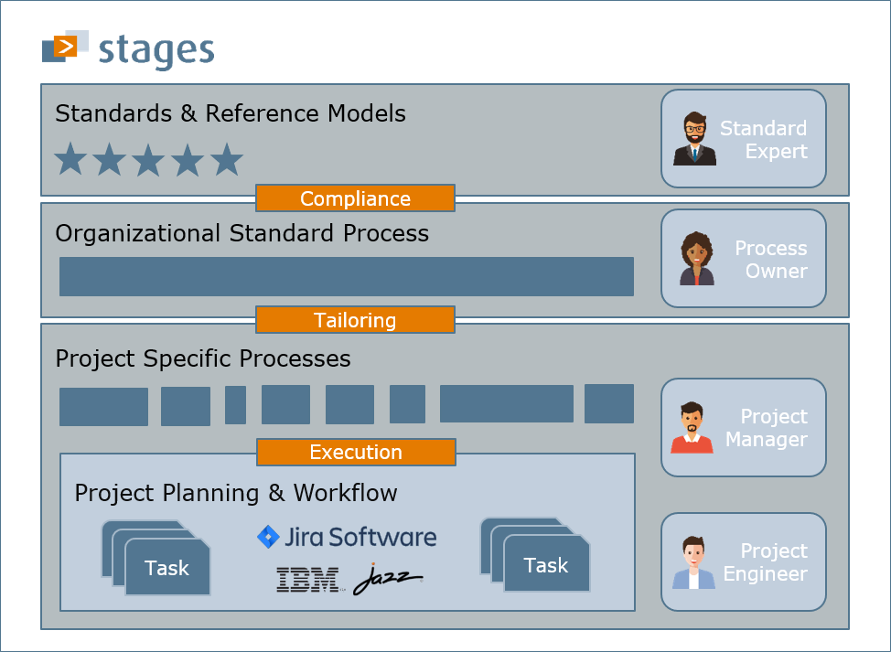
New Stages 7.6 Integration with Atlassian Jira und IBM Engineering Workflow Management

