Press Release

Method Park offers Process Solution for more Agility
New Stages Version 7.3 for product development processes now available
Method Park brings a new version of its engineering process management tool “Stages” to the market. With the new version 7.3, Method Park strengthens its offering for complex product development.
Erlangen, April 9, 2019 – Agile organizations need to be able to continuously improve their engineering practices– even if development programs have already been started. The new Stages version 7.3 enables the optimization of processes in-flight while already completed activities and phases remain unchanged.
New Algorithm
Method Park has therefore developed a new algorithm which consistently freezes completed process elements – across all phases and subprojects of complex development programs. The non-frozen parts of the processes can still be continuously updated and optimized. This provides Stages customers, especially those in the automotive and aerospace industries, with a capability to introduce improvements in an agile way, particularly for multi-year R&D programs.
Cooperation with OEM
“This new feature was developed in cooperation with one of the worldwide largest automotive OEMs”, says Dr. Erich Meier, CTO and Chief Architect of Stages. “We are very proud of our close cooperation with leading manufacturers of every industry we serve. They give us valuable insights into innovative engineering practices which allows us to continuously optimize our product. As a result, our customers can transform their engineering much faster and so successfully embrace global mega trends such as electrification, autonomy and digitalization.”
Quantitative Process Management
Stages 7.3 also offers improved support for harmonization of large processes and provides instant insights through live usage statistics. User feedback is now automatically collected as tickets in Jira to enable agile management of process change requests. Process managers can use this data to focus on the relevant processes and lead their organizations towards achieving quantitative process improvements. As an early adaptor, one of the largest manufacturers in the aerospace industry has already used this feature and became four times faster in implementing process change requests for its product development.
Please find more information on Stages, its features, and benefits on the Method Park website:
https://www.methodpark.com/stages.html
Number of characters (space characters included): 2.313 characters
About Method Park
Method Park specializes in complex product engineering for the automotive, medical, and aerospace industries. Method Park’s portfolio includes consulting and engineering services, a comprehensive training program and the process management tool “Stages”.
Method Park was founded in 2001. On a worldwide basis, the company has supported and coached its customers on process optimization, compliance to industry-specific standards and legal regulations, as well as the management of projects, products and quality assurance. Method Park offers a practice-based training program on all current topics of Software & Systems Engineering. In 2017, Method Park became official VDA QMC training provider of Automotive SPICE® courses. For the recent version of Automotive SPICE® V3.1, Method Park has developed a free app for iOS and Android.
With “Stages”, Method Park offers a model-based process management tool, which supports its users on the definition, communication and application of complex processes, particularly in the engineering environment – globally, beyond organizational borders and always in compliance with various industry-specific standards.
With around 200 employees, the company group has locations in Erlangen, Frankfurt on the Main, Hamburg, Munich and Stuttgart as well as in Detroit, Miami and Pittsburgh in the US. In 2018, Method Park generated an operative turnover of about 19 million euros.

For further information please contact:
Bernd Langer, Business Development
Method Park Software AG, Wetterkreuz 19a, 91058 Erlangen
Bernd.Langer@methodpark.de www.methodpark.com
Available pictures:
Stages Logo
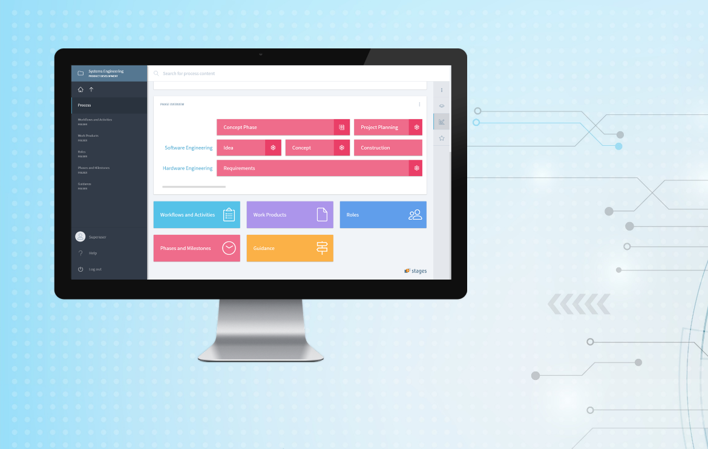
Phase Freeze feature in Stages V7.3

