Press Release

Method Park receives German Brand Award 2018
Repeat award for Method Park’s Employer Branding Campaign “Love what you do”
Method Park received an award for its employer branding by the jury of the German Grand Award 2018 in the categories “Employer Brand of the Year” and “Telecommunication & IT”.
Erlangen, June 26, 2018 – Method Park belongs to the winners of the German Brand Award 2018. The award ceremony took place on Thursday evening with a festive gala in the German Historical Museum in Berlin. Method Park received the award for the categories “Employer Brand of the Year” and “Telecommunication & IT”. Philipp Donnert of Method Park, and Sabine Fuchs and Marcel Rothenbusch of Comdeluxe, the advertising agency responsible for the campaign, received the award together.
With “Love what you do”, Method Park developed a range of measures to recruit employees. The Method Park departments HR and Marketing, created an innovative internal recommendation system and branded food trucks with which they visited different job fairs. In the first year alone, Method Park was able to recruit 40 new colleagues with this campaign.
In 2017, Method Park already won an award for its campaign “Love what you do”: the German Design Award 2017 of the German Design Council for the category “Integrated Campaigns and Advertising”.
With the German Brand Award, the Design Council and the German Brand Institute honor successful brands, consistent brand management and sustainable brand communication. The German Brand Award was initiated by the Design Council which was founded in 1953 by the German Bundestag and is funded by the Federal Association of German Industry. For over 60 years, this foundation has promoted competitiveness of German companies. The German Brand Institute organizes this competition which took place for the third time in 2018.
For further information see: https://www.german-brand-award.com/preistraeger/galerie/detail/19306-method-park.html and https://www.german-brand-award.com/preistraeger/galerie/detail/19307-method-park.html
Number of characters (space characters included): 1.843
About Method Park
Method Park is specialist for innovative software and systems engineering in the safety-critical environments of the medical and automotive industries. Method Park’s portfolio includes consulting and engineering services, a comprehensive training program and the process management tool “Stages”.
Method Park was founded in 2001. On a worldwide basis, the company has coached its customers on process optimization, compliance to industry-specific standards and legal regulations. It has also consulted on the management of projects, products and quality assurance.
Method Park offers a practice-based training program on all current topics of software and systems engineering. Method Park offers training at its locations in Germany and other European countries, the US and Asia.
With “Stages”, Method Park offers an individually customizable process management tool which supports its users on the definition, communication and application of complex processes.
The company group has locations in Erlangen, Frankfurt on the Main, Hannover, Munich and Stuttgart as well as in Detroit, Miami and Pittsburgh in the US. With around 170 employees, Method Park generated an operative turnover of about 16 million euros in 2017.
For further information please contact:
Dr. Christina Ohde-Benna, PR-Assistant
Method Park Holding AG, Wetterkreuz 19a, 91058 Erlangen, Germany
Christina.Ohde-Benna@methodpark.de www.methodpark.com
Available pictures:
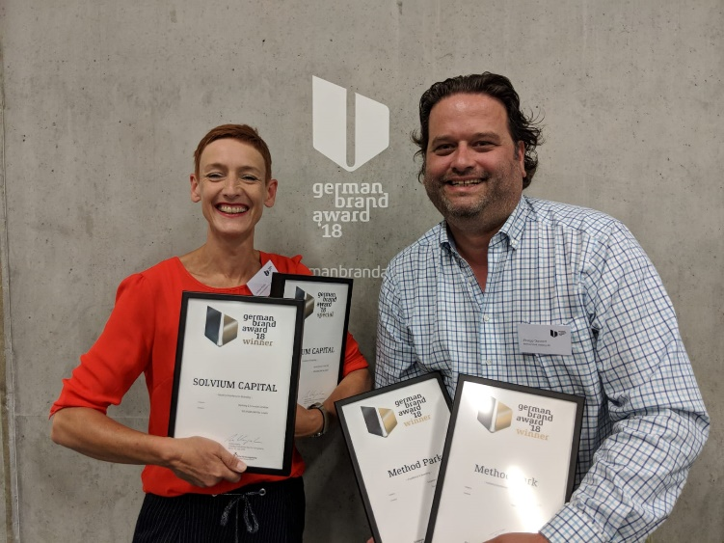
Sabine Fuchs (Comdeluxe) and Philipp Donnert (Method Park) are happy about winning the German Brand Award 2018.
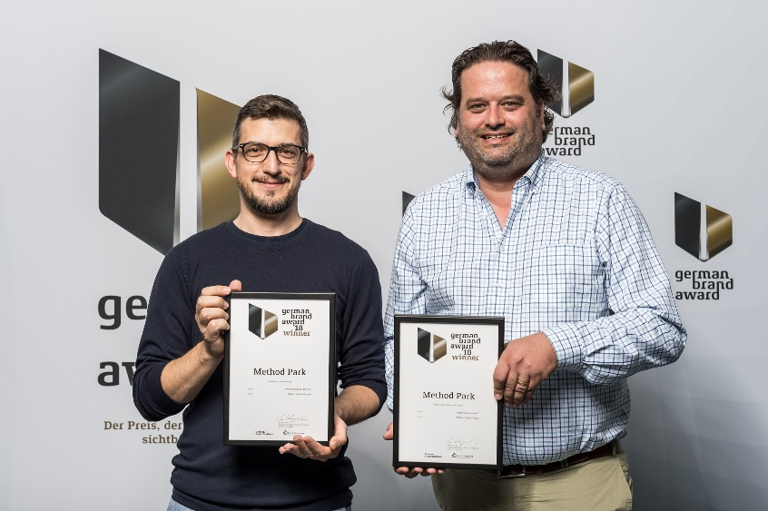
Marcel Rothenbusch (Comdeluxe) and Philipp Donnert (Method Park) show the certificate of the German Brand Award 2018.
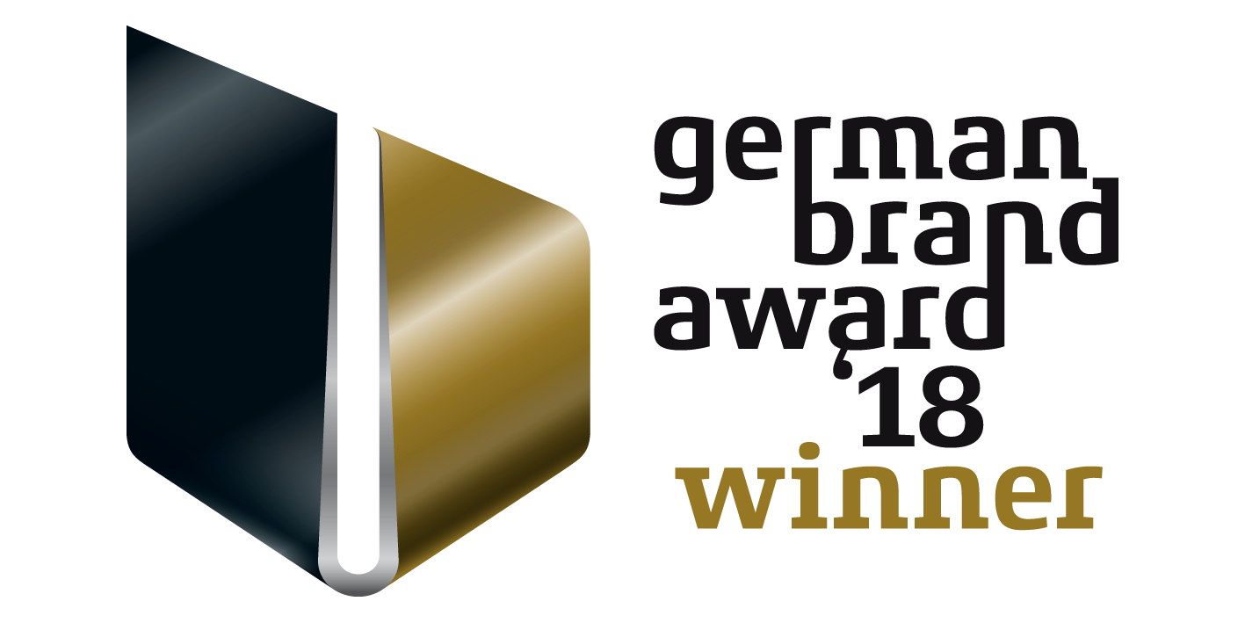
Logo of the German Brand Award 2018

