Press Release

Method Park successfully re-certified according to DIN EN ISO 13485:2016
TÜV Rheinland confirms certification of the Method Park quality management system
Following an inspection by TÜV Rheinland, Method Park's quality management system continues to meet the strict requirements of DIN EN ISO 13485.
Erlangen, March 7, 2019 - In November, Method Park successfully completed the re-certification of its quality management system according to DIN EN ISO 13485:2016. TÜV Rheinland now issued the official certificate. The Erlangen-based software and system house was first certified according to this DIN standard (version 2012) in 2015. The annual audits carried out over the past three years had confirmed each certification.

Routine preparation
With the experience gained in the last certification, the Method Park quality team was able to prepare the quality management system for the requirements of the new standard version of 2016 in less than three quarters, and TÜV Rheinland needed only two days for the inspection.

Advantages for the customer
Method Park customers in the medical technology industry can continue to rely on the fact that the company's quality management system and development processes meet the high regulatory requirements of the ISO standard.
"Our customers can be sure: Method Park is and remains a certified, competent, and reliable partner in medical technology," states Dr. Martin Geier, Managing Director of Method Park Engineering GmbH.

The DIN EN ISO 13485:2016
DIN EN ISO 13485 defines the harmonized, official requirements for the quality management system of medical device manufacturers. The version of 2016 replaces the requirements of the previous version of 2012 and brings further conformity with the American 21 CFR part 820 (Quality System Regulations). The new version also gives already well-known European regulatory requirements more significant consideration.
The standard is internationally recognized and has always provided guidelines for the design and development, production, installation, maintenance, and distribution of medical devices. In the new version of 2016, companies that store medical devices offer technical service or are suppliers, and service providers also receive concrete specifications.
Number of characters (space characters included): 2.251
About Method Park
Method Park specializes in complex product engineering in the environments of the automotive, medical, and aerospace industries. Method Park's portfolio includes consulting and engineering services, a comprehensive training program, and the process management tool "Stages".
Method Park was founded in 2001. On a worldwide basis, the company has coached its customers on process optimization, compliance to industry-specific standards and legal regulations. It has also consulted on the management of projects, products and quality assurance.
Method Park offers a practice-based training program on all current topics of software and systems engineering. Method Park offers training at its locations in Germany and other European countries, the US and Asia.
With "Stages", Method Park offers an individually customizable process management tool which supports its users on the definition, communication and application of complex processes.
The company group has locations in Erlangen, Frankfurt on the Main, Hamburg, Munich and Stuttgart as well as in Detroit, Miami and Pittsburgh in the US and Shanghai in China. Today, about 200 employees work for Method Park. In 2018, Method Park generated an operative turnover of about 19million euros.
For further information please contact:
Dr. Christina Ohde-Benna, PR-Assistant
Method Park Holding AG, Wetterkreuz 19a, 91058 Erlangen, Germany
Christina.Ohde-Benna@methodpark.de www.methodpark.com
Available pictures:
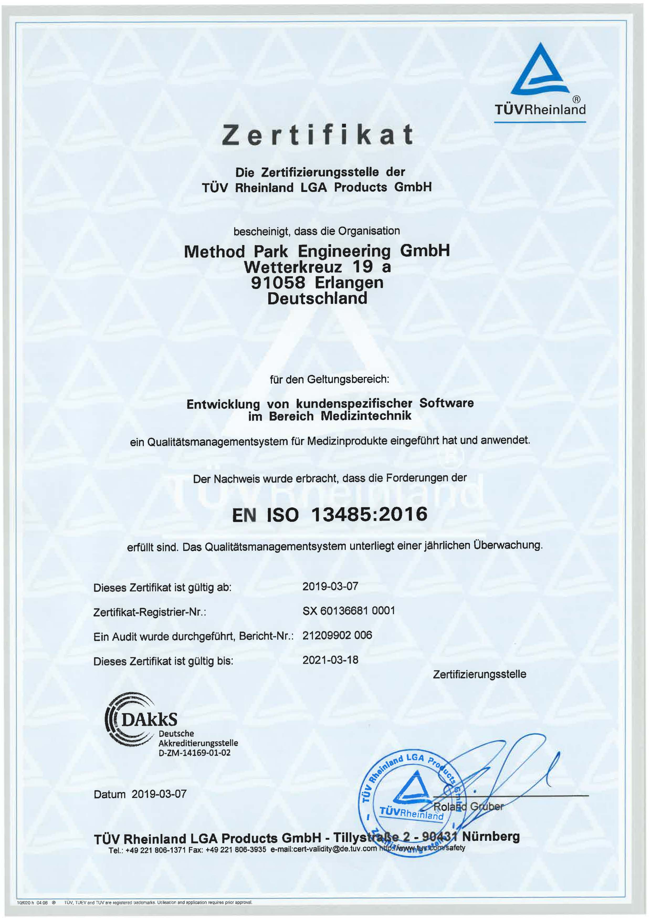
Method Park's Re-Certification Document

