Press Release

Stages Insights 2017: Agenda of Method Park conference reflects success of the product “Stages”

Presentations of Stages customers such as BMW, BSH Hausgeräte, Drägerwerk and ebm-papst St. Georgen show that the process management tool “Stages” has established across all industries.

Erlangen, April, 4, 2017 – Almost 100 participants joined the Method Park conference in Fürth on March 29 to learn more about how to apply and live processes in practice. This conference took place for the eleventh time in succession and presentations and discussions again focused on methods and tools for successful process management.
Method Park offers such a process management tool with “Stages”. After the cloud release of the latest Stages Version V7 in November 2016, CTO Dr. Erich Meier presented new developments and the future roadmap at the conference in Fürth. Some of the participating companies are already using Stages V7 as a test version. Method Park is continuously interacting with these customers to include their feedback into future implementation plans. News about V7 was well received by the conference audience.
Prof. Dr. Bernd Hindel explained the value of process modularization in his presentation “Higher Efficiency with Process Patterns”. In his presentation “Rapid Automotive SPICE Compliance with a Standard Process”, Dr. Holger Höhn demonstrated how to quickly establish Automotive SPICE® compliance in organizations.
Method Park is particularly proud of the four customer presentations held by representatives of BMW, BSH, Drägerwerk and ebm-papst who demonstrated their successful work with Stages and proofed that methodical approaches combined with project-specific adjustment and automated process implementation make product development far more efficient.
This year, the futurologist Erik Händeler concluded the conference with presentation “The history of future”.
In addition to presentations, conference participants had the opportunity to seek individual advice and solution approaches on company-specific challenges from Method Park experts in the Consulting Café which was booked up this year again. Furthermore, conference participants had the chance to network and have discussions with other participants at Stages Insights and get informed and exchange experience with experts at the Method Park and PEDCO booths. Executives from companies of different sectors such as IAV, RUAG Space, HERE, BRP, Continental Automotive, Hella, Schaeffler, ZF Friedrichshafen or Siemens Healthcare were among the conference participants.
This year, Method Park offered its “Process Management 4.0” workshop on the following day again. This workshop consists of five core steps for effective implementation of process management for all industries.
Method Park plans the Stages Insights conference for spring 2018 again: “The upcoming Stages Version 7 is the biggest step in innovation in the tool’s history of 15 years. In 2018, we would like to present practical experience of our customers”, says Dr. Erich Meier.
Number of characters (spaces included): 3.023
About Method Park
For many years Method Park has successfully offered consulting in questions of software for safety-critical systems in the automotive industry and in the medical technology area, for which the company develops its own software solutions. Method Park brings extensive know-how to fields with high and extremely high safety requirements. With this knowledge Method Park offers its customers a variety of solutions from a single source that contribute to the success of each company. Method Park is the competent partner for consulting, coaching, training, engineering services and products for all questions of software development processes. The "Stages" Web-based process management portal developed by Method Park supports users with the practical implementation of development processes. Stages ensures the realization of predefined quality standards and process models and can be integrated in all common development environments. Furthermore, Stages enables the global distribution of development tasks beyond corporate boundaries. Founded in Erlangen in 2001, Method Park employs around 160 persons at sites in Erlangen, Munich, Hannover and Stuttgart, as well as in Detroit and Miami in the USA.
For further information please contact:
Dr. Christina Ohde-Benna, PR-Assistant
Method Park Holding AG, Wetterkreuz 19a, 91058 Erlangen, Germany
Christina.Ohde-Benna@methodpark.de www.methodpark.de
Available pictures:
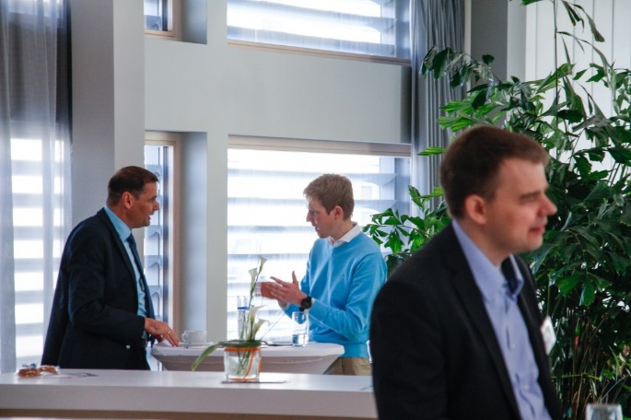
In the Consulting Café, conference participants used the opportunity to seek advice from experienced consultants for free.

