Press Release

Method Park CEO receives the German Award for Software Quality

Prof. Dr. Bernd Hindel receives an award for his contribution to software quality. The German Award for Software Quality is awarded by the ASQF e.V.

Erlangen, December, 7, 2016 – During its 20th anniversary, the German Association for Software Quality and Further Education ASQF e.V. awarded Method Park CEO Prof. Dr. Bernd Hindel with the German Award for Software Quality yesterday in Berlin.
In 2011, the ASQF e.V. started to annually award persons, companies and initiatives or institutions which particularly contributed to the preservation, development or research in software quality. Everyone can suggest candidates for this award and an independent advisory board, which is appointed by the members of the ASQF e.V. management, decides who will win the award.
Prof. Dr. Bernd Hindel is founding member of ASQF e.V. and was president until 2007. Dr. Walter Wintersteiger, who was awarded in 2013, emphasized in his tribute commendation that this award honors the lifetime achievements of Prof. Dr. Hindel. The recipient founded influential organizations such as intacs e.V. (certification of SPICE assessors) and ASQF; contributed to the German Standards Institute (DIN); and was representative for Germany at the International Organization for Standardization (ISO) for software and systems engineering standards. He successfully established the company Method Park, which develops engineering processes on three continents.
Number of characters (spaces included): 1.496
About Method Park
For many years Method Park has successfully offered consulting in questions of software for safety-critical systems in the automotive industry and in the medical technology area, for which the company develops its own software solutions. Method Park brings extensive know-how to fields with high and extremely high safety requirements. With this knowledge Method Park offers its customers a variety of solutions from a single source that contribute to the success of each company. Method Park is the competent partner for consulting, coaching, training, engineering services and products for all questions of software development processes. The "Stages" Web-based process management portal developed by Method Park, supports users with the practical implementation of development processes. Stages ensures the realization of predefined quality standards and process models and can be integrated in all common development environments. Furthermore, Stages enables the global distribution of development tasks beyond corporate boundaries. Founded in Erlangen in 2001, Method Park employs around 130 persons at sites in Erlangen, Munich and Stuttgart, as well as in Detroit and Miami in the USA.
For further information please contact:
Dr. Christina Ohde-Benna, PR-Assistant
Method Park Holding AG, Wetterkreuz 19a, 91058 Erlangen, Germany
Christina.Ohde-Benna@methodpark.de www.methodpark.de

Available pictures:
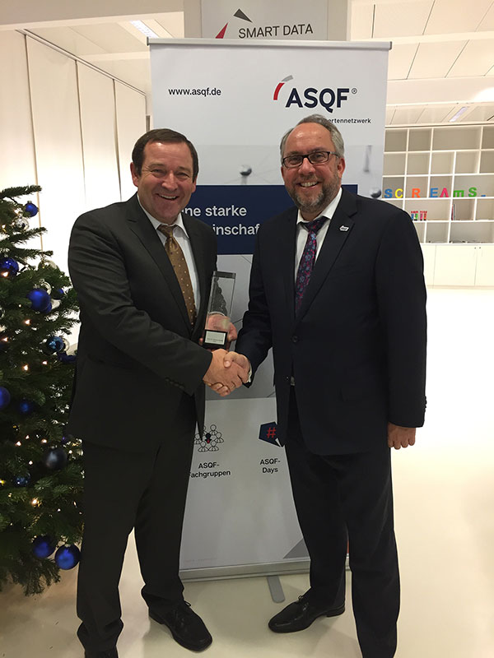Stephan Goericke, General Manager of ASQF congratulates Prof. Dr. Bernd Hindel on the German Award for Software Quality.

